System – Email Forwarding
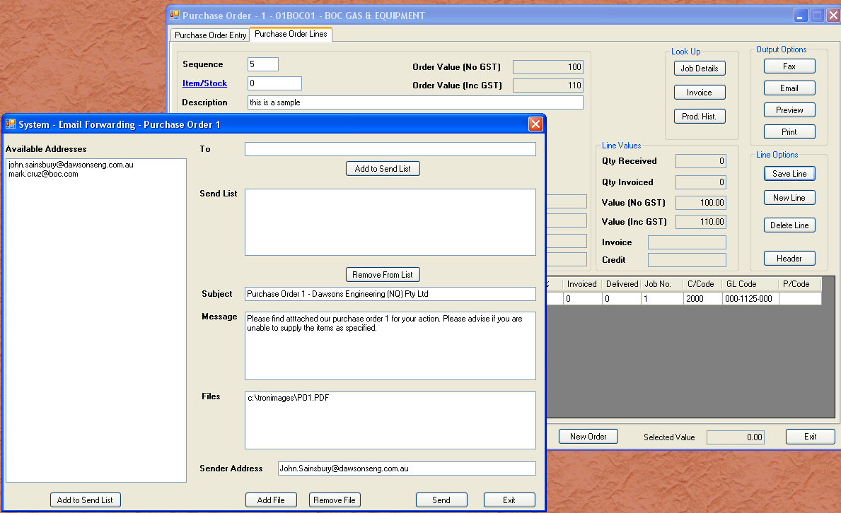
Email forwarding is a module that is called from several locations. In this case it was called from the purchase order. By default, the email address come from those set in the creditor master. It will add all purchasing addresses as well as the accounts address.

If the module was called from somewhere else, example debtors, then the email addresses would come from the debtor master. Simply select and email address, or add your own. You have the file of a purchase order already attached. The message is also tailored to a purchase order. You could add more files, simply by clicking “Add File”.

When a record is sent, the details are recorded in a system file. A future release of Tron will include the ability to review send system messages. For now the transaction is recorded. If the email should fail, you will be sent an email to your address.

